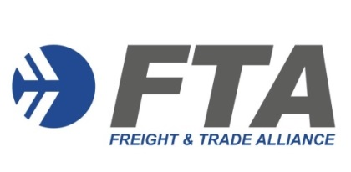
MEMBERSHIP APPLICATION FORM
Freight & Trade Alliance Pty Ltd
ABN: 5916 0523 384
PLEASE NOTE:
- Individual Membership is open to all professionals involved in international trade
- Cost is $264 (including GST) per annum
- Membership is aligned to the Customs Broker Continuing Professional Development (CPD) / Approved Person Continued Biosecurity Competency (CBC) period (1 April to 31 March)

Please forward the completed form to Caroline Zalai czalai@FTAlliance.com.au
Applicant details
Business Name: ________ ABN: _______
Contact Name: ________ Position: ____
Address: ____________________ ________
Mailing Address: ____________________________________________________________________________
Phone: Mobile: ____ Email: ______
Web Address: _______________________________________________
Individual Subscription
Customs Broker Licence Number ___________________
Dept of Agriculture Water & the Environment (DAWE) Accreditation Number ______________
Class 19.1 (NCCC) Class 19.2 (AEPCOMM)

Terms & Conditions
FTA will issue a tax invoice on receipt of the above information. Payment Terms are 14 days (EFT, credit card or cheque).
Signature / Name ________ Date ____

