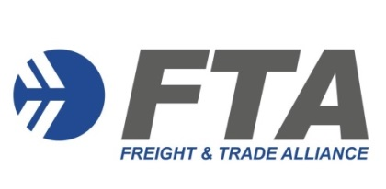
MEMBERSHIP APPLICATION FORM
INDIVIDUAL
Freight & Trade Alliance Pty Ltd
ABN: 5916 0523 384
PLEASE NOTE:
- Individual Membership is open to all professionals involved in international trade
- Cost is $330 (including GST) per annum
- Membership is aligned to the Customs Broker Continuing Professional Development (CPD) / Approved Person Continued Biosecurity Competency (CBC) period (1 April to 31 March)
- Only Training & Event communications are included in this level of membership
Please forward the completed form to Caroline Zalai czalai@FTAlliance.com.au for processing.
Applicant details
Business Name: _______________________________________ ABN: ____________________________
Contact Name: _________________________________________Position: ______________________
Address: ___________________________________________________________________________
Mailing Address: _____________________________________________________________________________
Phone: ____________________Mobile: ____________________ Email: __________________________
Web Address: _______________________________________________________________________
Individual Subscription
Customs Broker Licence Number ________________________________
Department of Agriculture, Fisheries & Forestry (DAFF) Accreditation Number ____________________
Class 19.1 (NCCC) Class 19.2 (AEPCOMM)

Terms & Conditions
FTA will issue a tax invoice on receipt of the above information. Payment Terms are 14 days (EFT, credit card or cheque).

Signature / Name __________________________________ Date ___________________________________

