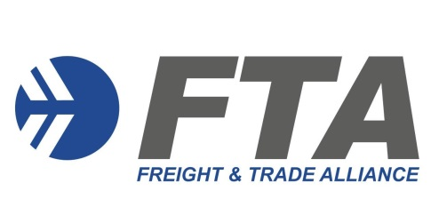
MEMBERSHIP APPLICATION FORM
AFFILIATE
Freight & Trade Alliance Pty Ltd
ABN: 5916 0523 384
Please forward the completed form to Caroline Zalai czalai@FTAlliance.com.au
Applicant details
Business Name: ________ ABN: _______
Contact Name: ________ Position: ____
Address: ____________________
Mailing Address: ________________________________________________________________________
Phone: Mobile: ____ Email: ______
Website: ___________________________________________
Terms & Conditions
FTA will issue a tax invoice on receipt of the above information. Payment Terms are 14 days (EFT, credit card or cheque).
- FTA will issue a username and password allowing access to restricted information and a search engine for archived content
NOTE: FTA encourages dissemination of the password details to all employees (multiple staff can be logged in at the same time). The username and password must not to be provided to any external business entity or individual. Should a breach of this condition occur, FTA may terminate the subscription and the subscriber will forfeit the current period’s subscription fee.

- FTA will provide the "FTA - Your Business Partner" Logo (.eps and .jpeg)
NOTE: The intended use of the logo must be approved by FTA before a subscriber may place it on a website or other communication materials;

- FTA will disseminate FTA notices/Weekly Reports to nominated contacts
NOTE: subscribers should nominate recipients by providing email address and name to Caroline at czalai@ftalliance.com.au or complete details directly on the following URL
http://ftalliance.us6.list-manage2.com/subscribe?u=e9d77c8ae8&id=1e8159378a
Signature / Name ________ Date ____
Directory Listing
Please provide the following information for each state office for inclusion on the FTA directory at www.FTAlliance.com.au and delivery of complimentary quarterly ‘Across Borders’ magazine.

Business Name

Contact Name

Phone

Email

PO Box Address
FTA - Across Borders Magazine delivery

Office suburb / state

Business Name

Contact Name

Phone

Email

PO Box Address
FTA - Across Borders Magazine delivery

Office suburb / state

Business Name

Contact Name

Phone

Email

PO Box Address
FTA - Across Borders Magazine delivery

Office suburb / state

Business Name

Contact Name

Phone

Email

PO Box Address
FTA - Across Borders Magazine delivery

Office suburb / state

Business Name

Contact Name

Phone

Email

PO Box Address
FTA - Across Borders Magazine delivery

Office suburb / state

Business Name

Contact Name

Phone

Email

PO Box Address
FTA - Across Borders Magazine delivery

Office suburb / state

Business Name

Contact Name

Phone

Email

PO Box Address
FTA - Across Borders Magazine delivery

Office suburb / state

